NUMBER | Service Number | NAME | Surname
RANK | Rct | SUB-UNIT | Pirbright

1. DISPOSAL *

FIT FOR FULL DUTIES

TRG LIMITATIONS (SEE BELOW) |  | For |  | Days | Or until

ENTRY DEFERRED AT IMA ** | X | For |  | wks | Or until

2. LIMITATIONS *

X = EXCUSED |  | N/A = Not applicable
= PERMITTED

At IMA this Recruit has been found to have body composition which does not meet the standard required by AGAI 40.043 (see table below which applies from 18 years of age. Recruits who are under 18 must have a BMI of 17 - 29.9 and are not eligible for waist circumference
adjustment or SDC loading). AF B204 (Defect in Enlistment) documentation will be generated for them.

CURRENT MEASUREMENTS
Weight Read Code Fields - 22A kg

Height Read Code Fields - 229 cm

BMI Read Code Fields - 22K kg/m²

Waist Circumference Read Code Fields - 22N0 cm

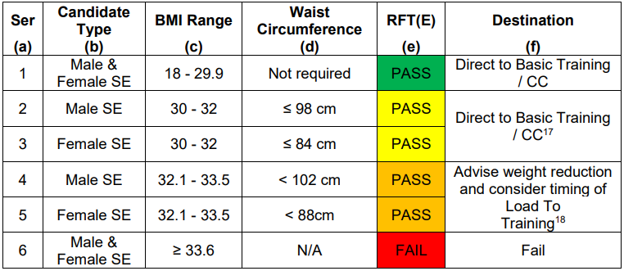

From JSP 950 6-7-7 Section 3 Annex C: "There is clear evidence that there is a significantly increased risk of musculoskeletal injury (particularly during military training and in females) in those with a low BMI. Similarly, there is evidence that in individuals with a high BMI there is decreased muscle endurance and an associated increase in fatigue."

NAME AND RANK | User Title User Name | DATE | System Date
SIGNATURE |  | EXT
PLATOON/TROOP STAFF SIGNATURE |  | DATE
RECRUIT’S SIGNATURE |  | DATE

Medical Reception Station  ATR Pirbright  Alexander Barracks  Pirbright  WOKING  Surrey GU24 OQQ  Tel: 01483 798300 / (94211) 8333 | MEDICAL CENTRE STAMP | IMPORTANT
 | MED CENTRE  ATR PIRBRIGHT  ALEXANDER BKS  PIRBRIGHT  GU24 0QQ | Sub-unit staff are responsible for ensuring recruits are aware of and attend all medical appointments
 |  | COPIES
 |  | Recruit | FMed 4 | Sub-unit

